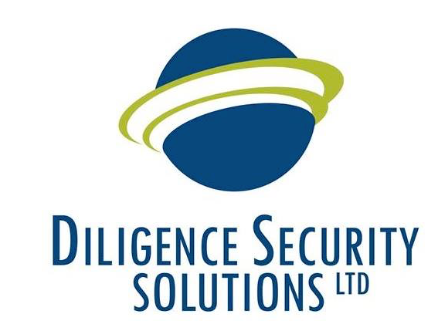 | Diligence Security Solutions Ltd  55 Warren Street  London  W1T 5NW  www.diligencesecuritysolutions.com

Grievance Procedure

1. It is important that if you feel dissatisfied with any matter relating to your employment you should have an effective means by which such a grievance can be aired and resolved fairly.

2. Nothing in this procedure is intended to prevent you from informally raising any matter you may wish to mention. Informal discussion can frequently solve problems without the need for a written record. However, if you wish to raise a formal grievance you should do so in writing to the Senior Management Team, through the email chain, from the outset. Whilst we will give consideration to any grievance that you raise verbally, provided that you make it clear that you wish it to be treated formally, you should be aware that, in most circumstances, we require you to provide us with written details of your grievance.

3. You have the right to be accompanied at any stage of the procedure by a fellow employee or union representative who may act as a witness or speak on your behalf to explain the situation more clearly.

4. If you feel aggrieved in a matter relating to your work (except personal harassment, for which there is a separate procedure, you should first raise the matter with a member of the Senior Management Team through the head office, explaining fully the nature and extent of your grievance. You will then be invited to a meeting at a reasonable time and location at which your grievance will be investigated fully. You must take all reasonable steps to attend this meeting. You will be notified of the decision, in writing, normally within ten working days of the meeting, including your right of appeal.

5. If you wish to appeal you must inform you’re a member of the Senior Management Team within five working days. You will then be invited to a further meeting, which you must take all reasonable steps to attend. As far as reasonably practicable, the company will be represented by a more senior manager than attended the first meeting (unless the most senior manager attended that meeting).

6. Following the appeal meeting you will be informed of the final decision, normally within ten working days, which will be confirmed in writing.

